 **THE UNIVERSITY OF BUEA** **REPUBLIC OF CAMEROON**

P.O Box 63, PEACE-WORK-FATHERLAND

Buea, Southwest Region

Cameroon

Tel: (237) 674354327

Fax: (237) 3332 22 72

**FACULTY OF ENGINEERING AND TECHNOLOGY**

**DEPARTMENT OF COMPUTER ENGINEERING**

**CEF 440: Internet programming and mobile programming**

**Design and Implementation of a Road Sign and Road State Mobile Notification Application**

Group 15

TASK 2: REQUIREMENT GATHRING

[GitHub - Asumu22/group-15](https://github.com/Asumu22/group-15)

Presented by:

|  |  |  |  |
| --- | --- | --- | --- |
| No | Name | Matriculation No | Specialty |
| 01 | KONGNYUY RAYMOND AFONI | FE21A219 | NE |
| 02 | BESONG ELIAS ASUMU | FE21A149 | SE |
| 03 | KANKO KEMEDJEU DUPLEX | FE21A210 | NE |
| 04 | KENEDY MALLEY ITUKA | FE21A212 | NE |
| 05 | AZEFACK JUNIOR | FE21A146 | NE |

**Dr. NKEMENI Valery**

**Course Supervisors**

**2023/2024 Academic Year**

Contents

1. Introduction 2

2. Requirement Gathering Techniques for the system 3

2.1 User Interviews: 3

2.2 Surveys: 4

2.2.1 Survey questions on google forms 4

2.2.2 Paper surveys and results sample paper 7

2.3 Research on existing systems and document 8

2.4 Brainstorming 10

3. Importance of Requirement Gathering 11

4.1 Why Requirement Gathering is Crucial for Our Road Sign and Road State Mobile Notification Application 11

Conclusion 12

11. References 13

TASK 2: REQUIREMENT GATHRING

# 1. Introduction

The ever-changing road environment necessitates real-time awareness of road signs and conditions for safe and efficient driving. This report documents the comprehensive requirement gathering process conducted for the development of a Road Sign and Road State Mobile Notification Application. Effective requirement gathering is crucial for the success of any mobile application by ensuring it meets user needs, delivers real value, and avoids costly development pitfalls. The report details the various stakeholder groups involved, user research methods employed, and the identified functional and non-functional requirements that will serve as the foundation for the application's design and development.

Drivers face significant challenges staying informed about road signs and state changes, especially in unfamiliar areas or encountering unexpected situations. Our proposed mobile application addresses this need by providing users with a comprehensive suite of features delivered through an Augmented Reality (AR) interface:

* **Real-time Road Sign Recognition and Information:** Utilizing the device's camera and computer vision techniques, the application will identify and display relevant road sign information overlaid directly onto the user's view of the road. This real-time sign detection (building upon datasets like the Vienna Convention of Road Signs) will include:
* Sign recognition and alerts (e.g., "school zone ahead," "stop sign").
* Visual representations of road signs to enhance recognition and understanding.
* Information about the signs' meanings and significance, promoting road safety compliance.
* **Up-to-date Traffic and Weather Information:** Real-time data integration with traffic management APIs and weather services will provide users with critical awareness of factors impacting road safety, displayed directly within the AR interface . This includes:
* Traffic congestion alerts.
* Accident notifications.
* Road closure updates.
* Weather-related hazards (e.g., rain, fog, snow).
* **Customizable Notification Preferences:** Users will be empowered to personalize their notification preferences within the application settings. This could include:
* Receiving alerts for specific road signs (e.g., prioritize stop signs and speed limit changes).
* Notifications for particular traffic or weather conditions (e.g., alerts only for heavy congestion or severe weather).
* The ability to set geographical boundaries for receiving alerts (e.g., receive notifications only on frequently traveled routes).
* **Augmented Reality Navigation (Optional):** This feature will provide turn-by-turn navigation instructions seamlessly integrated into the user's AR view using image processing and computer vision techniques. This can include:
* Arrows superimposed on the road view for clear navigation guidance.
* Real-time road boundary and lane detection .
* Integration with Maps API for route fetching and direction display.

# 2. Requirement Gathering Techniques for the system

We will employ a multi-pronged approach to gather requirements for our Road Sign and Road State Mobile Notification Application:

## 2.1 User Interviews:

* One-on-one interviews with drivers will provide in-depth insights into their experiences, preferences, and challenges related to road signs and road state awareness. Here are some potential interview questions:
* What are the biggest difficulties you face regarding road signs while driving?
* How do you currently stay informed about traffic conditions and road closures?
* What features would be most helpful in a mobile application for road signs and road state information?

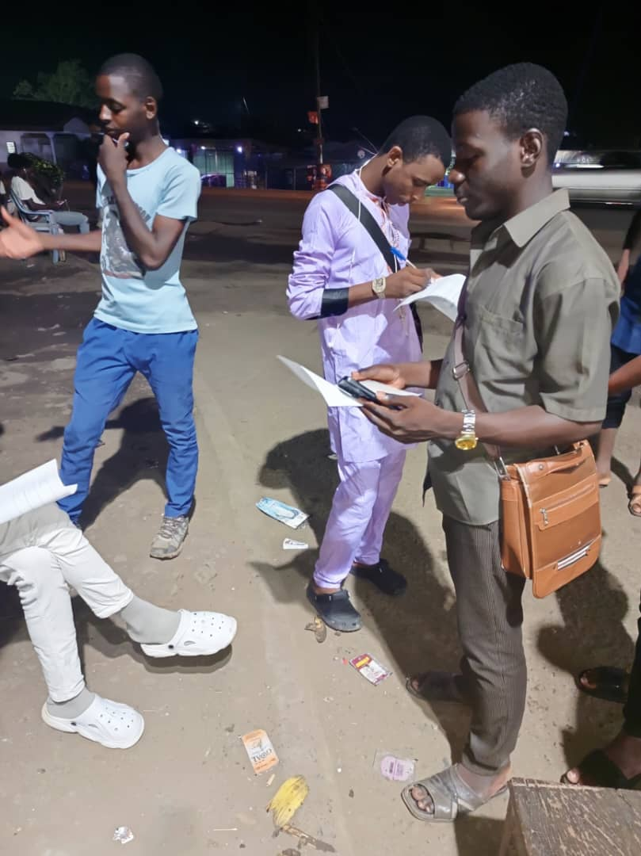

**Fig 1. Out station interview at on Buea streets**

## 2.2 Surveys:

Distributing online or paper-based surveys can reach a wider audience and provide valuable quantitative data on user needs and desired functionalities. Here are some potential survey questions:

**Survey done**

### 2.2.1 Survey questions on google forms

<https://docs.google.com/forms/d/e/1FAIpQLSczbn8ybZQeO1KS5gkgy33JgJIUX_yV8BEXuZElj797Lkh3yw/viewform?usp=sf_link&usp=embed_facebook>

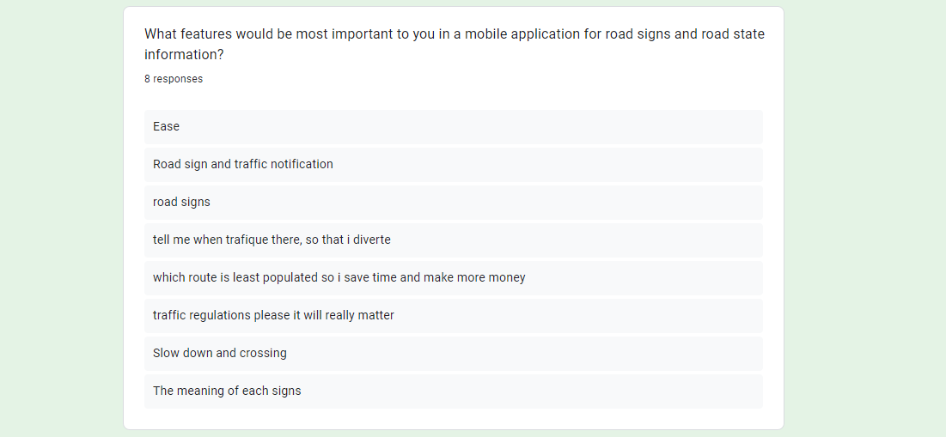

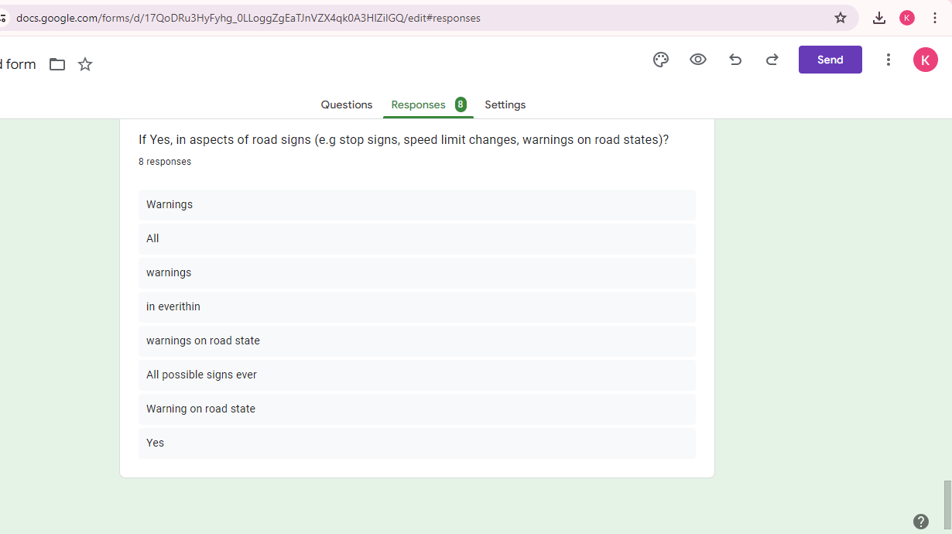

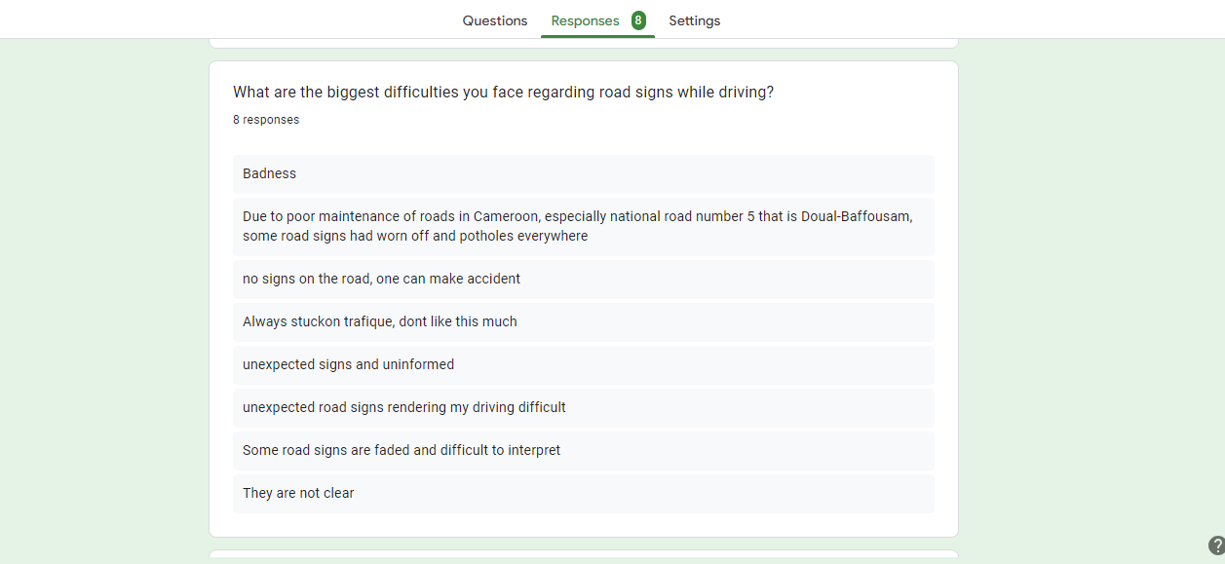

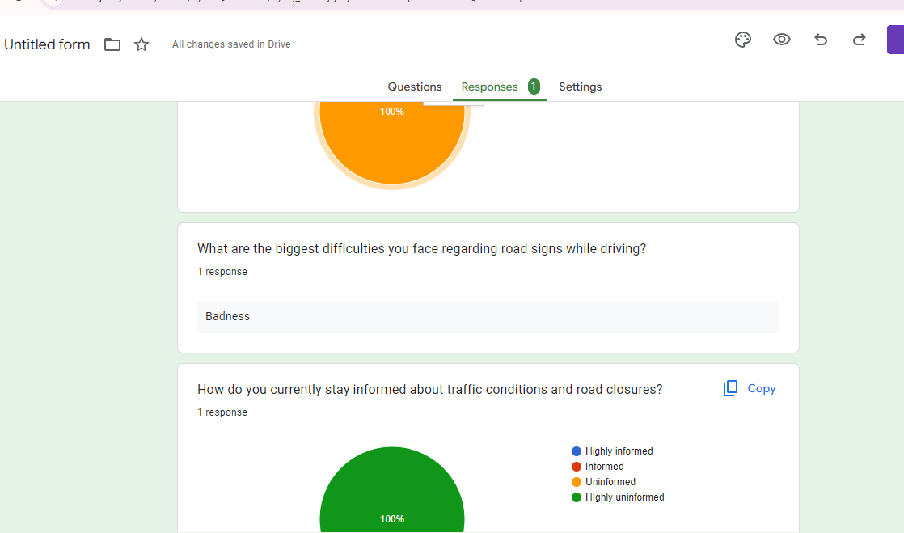

**results**



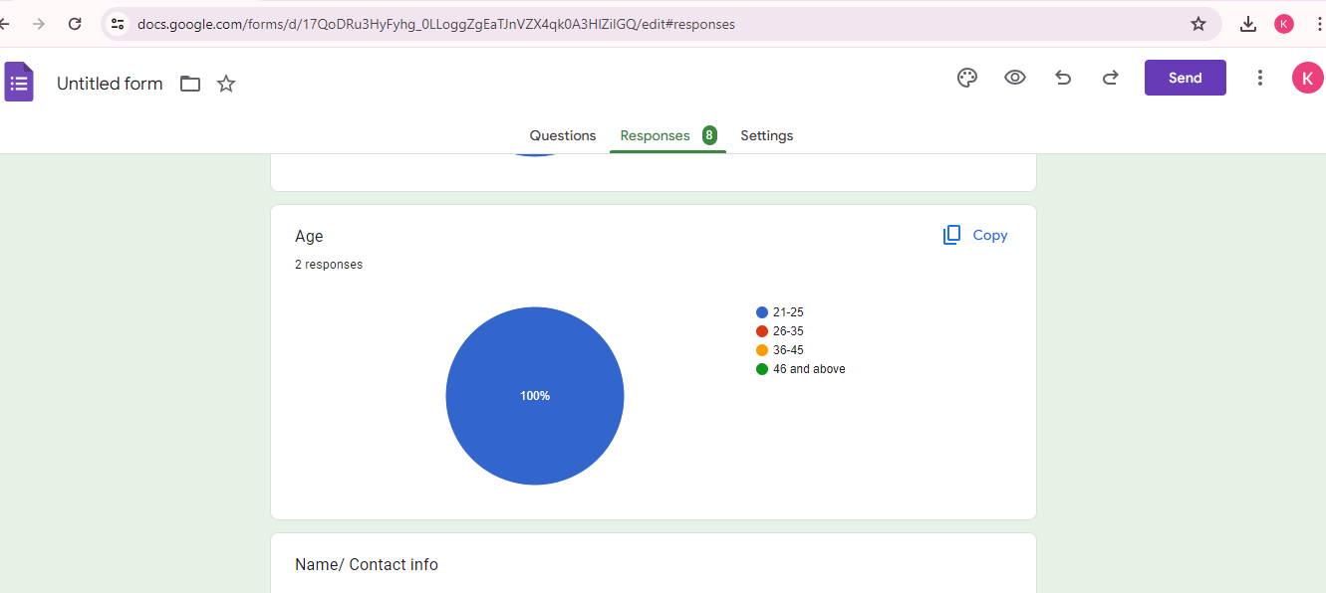

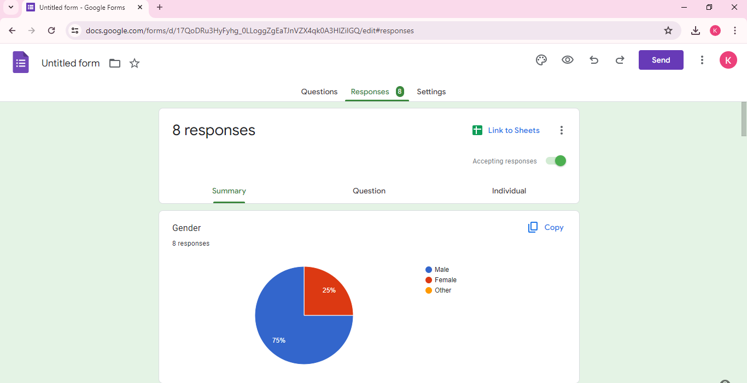

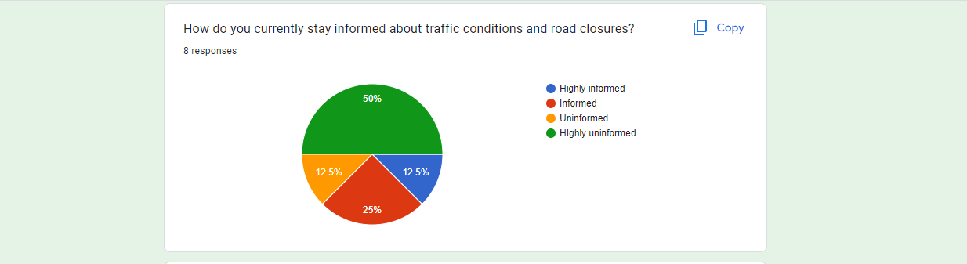

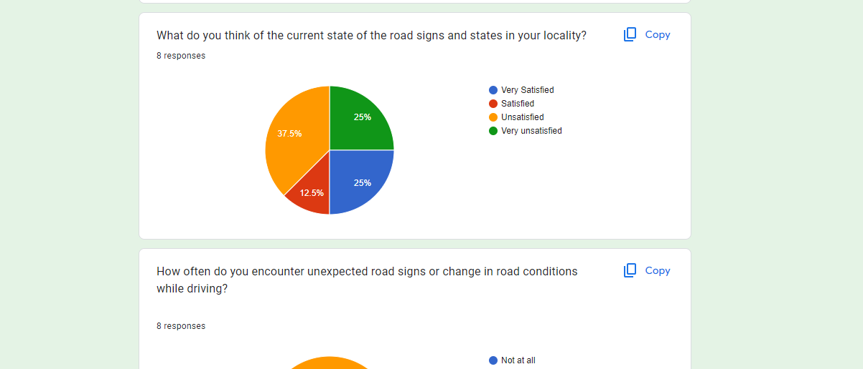

### 2.2.2 Paper surveys and results sample paper

This survey was done at the mile 16 to street 2 strait of rouad in Buea, and a sample survey paper displayed below

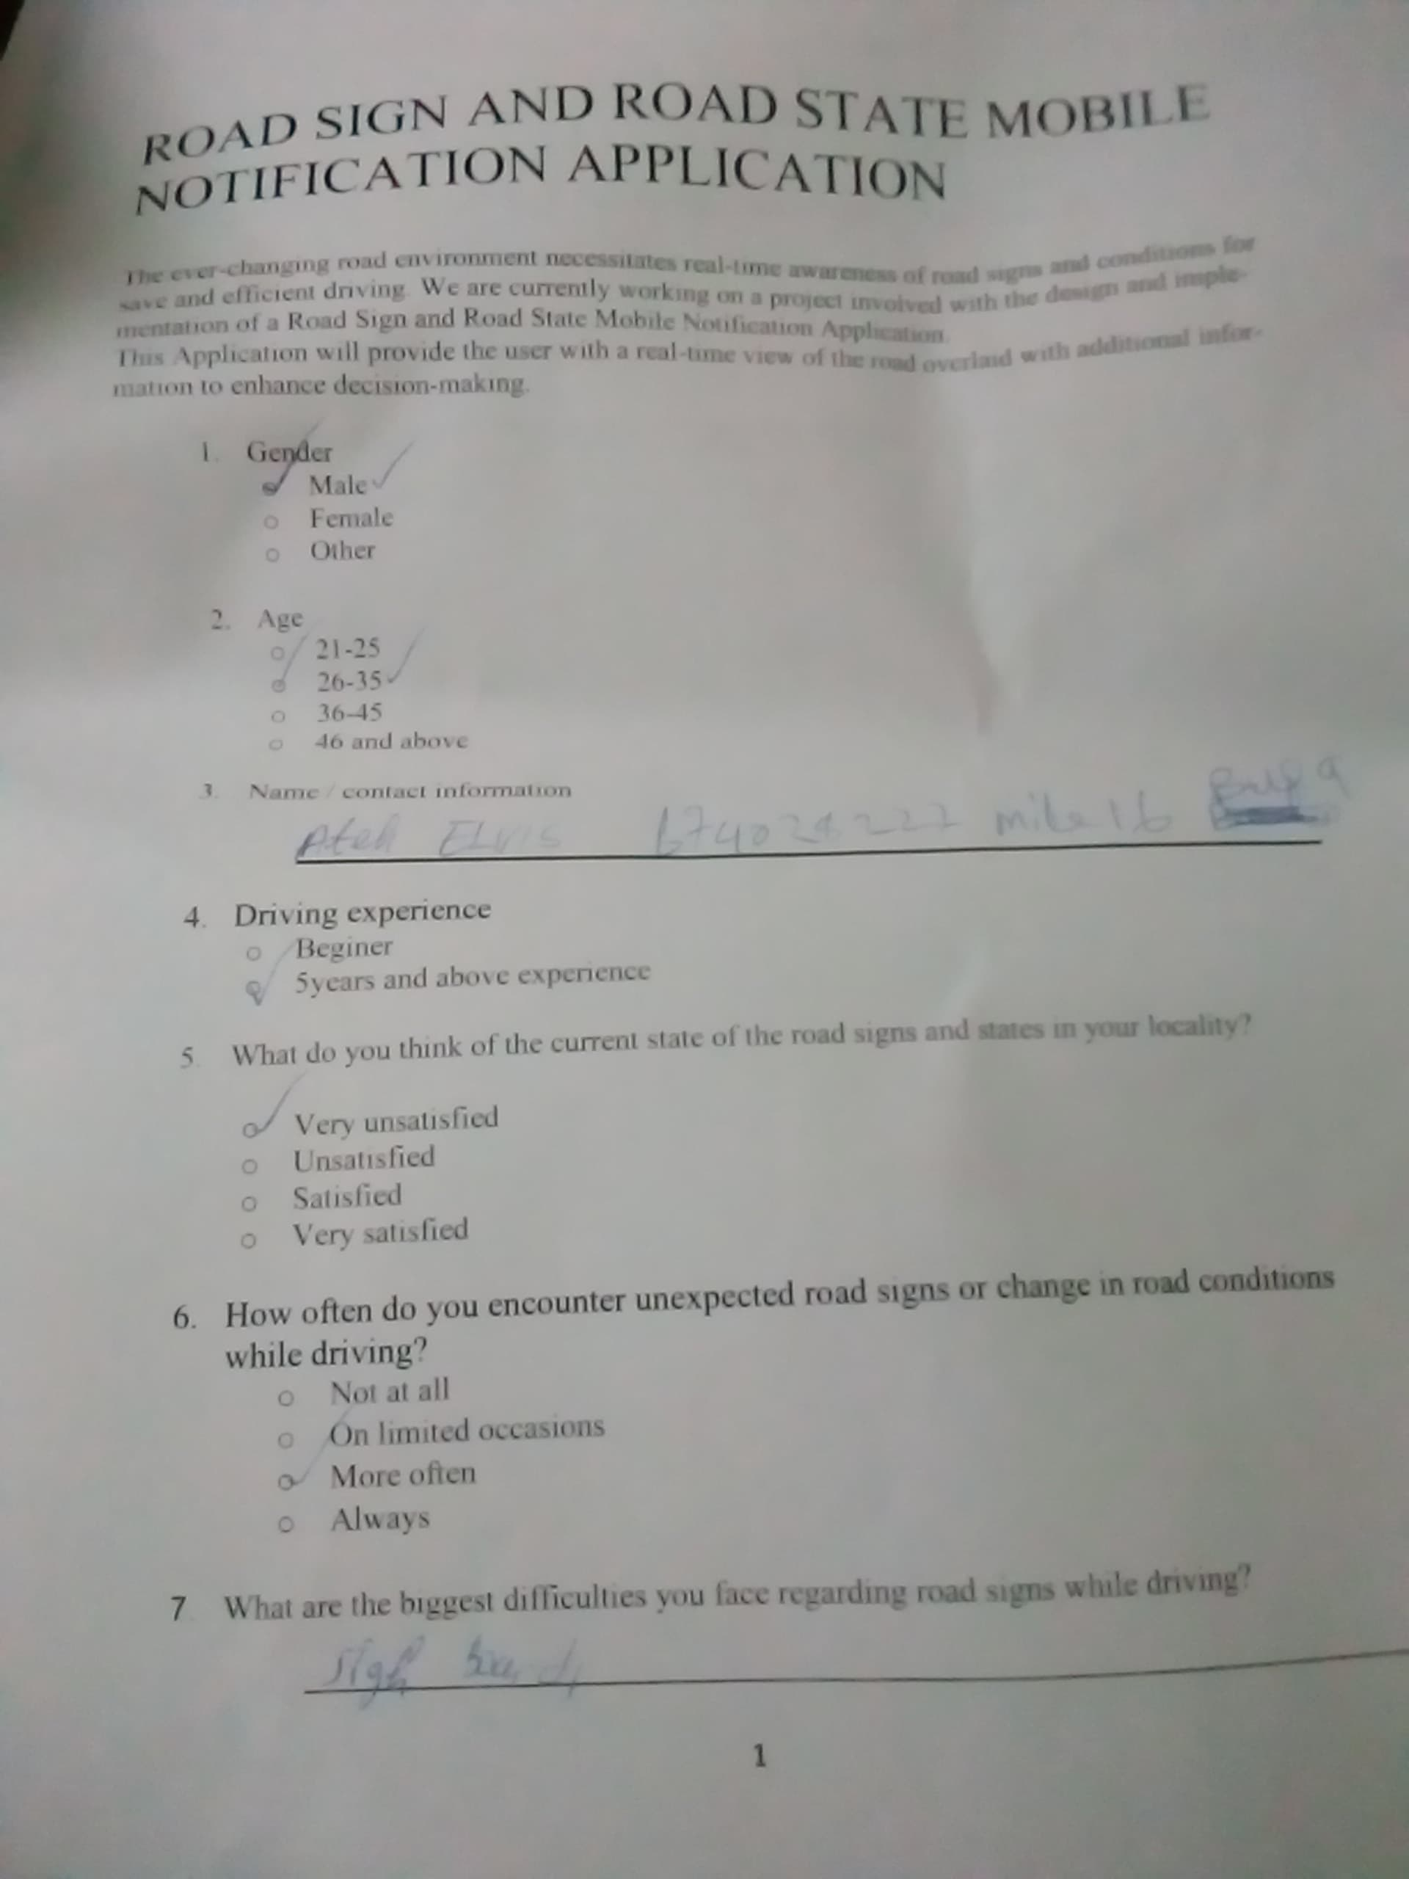

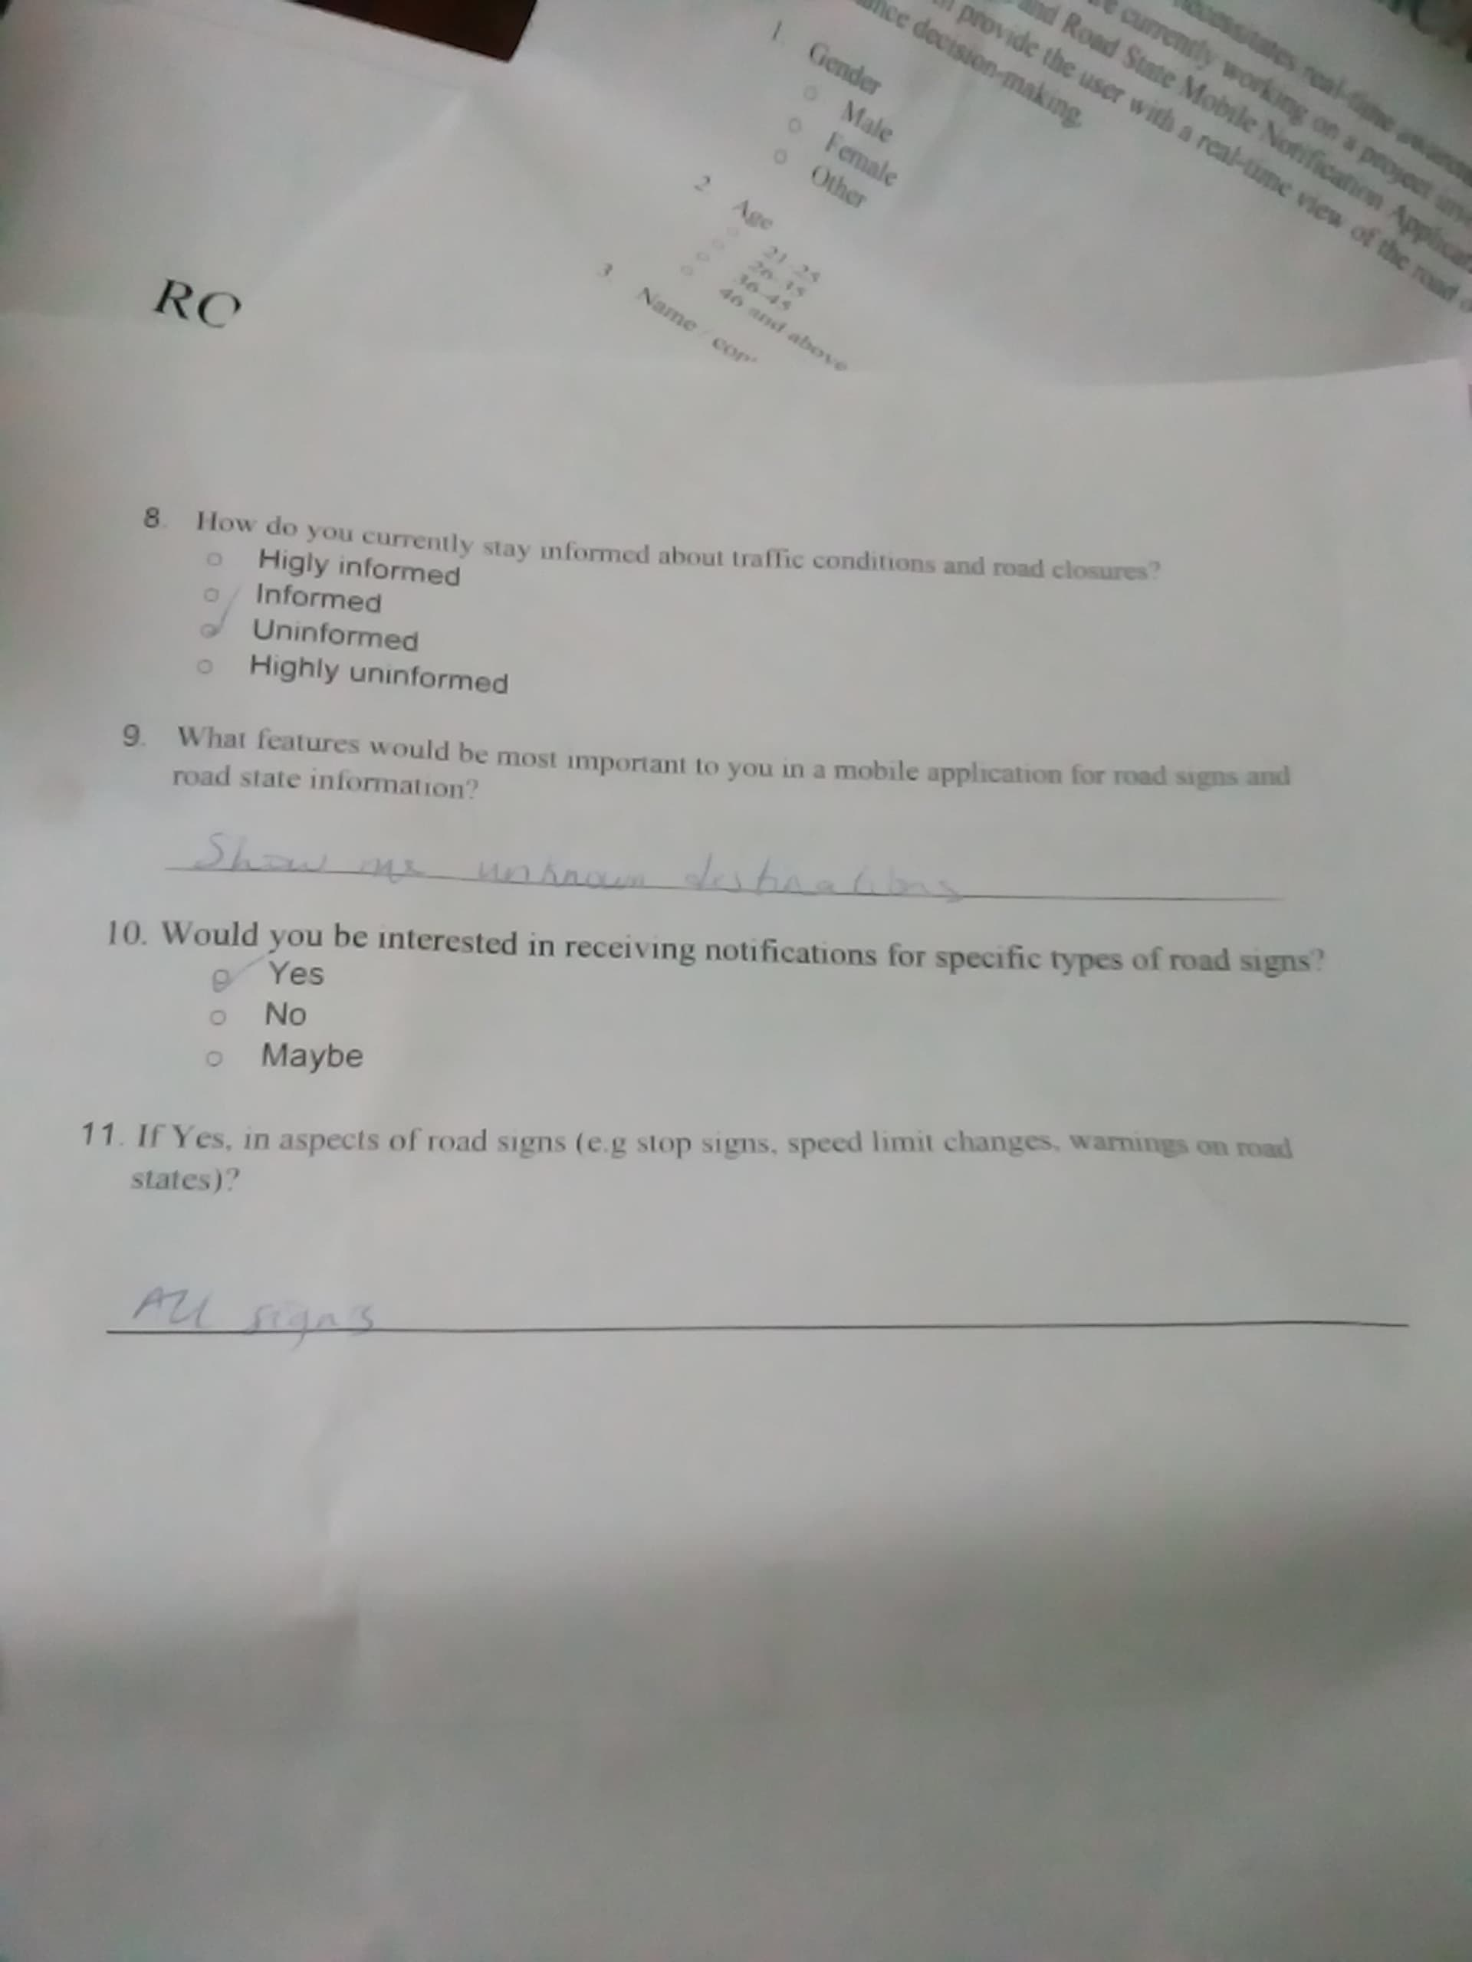

## 2.3 Research on existing systems and document

we have identified the following requirements:

* **Real-time Road Sign Recognition:**

The application will leverage computer vision techniques to identify and display relevant road sign information overlaid directly onto the user's view of the road using the device's camera

* **Location-Aware Information and Navigation:**
* **Location-based Information:** The application will use GPS to determine the user's location and display relevant road sign information overlaid on a map. This map integration will allow users to visualize their surroundings and road sign placements.
* **Real-time Road State Updates:** The application should provide real-time information about road conditions, including traffic congestion, accidents, construction work, and road closures.
* **Interactive Maps:** Users should be able to view road conditions on interactive maps, with options to zoom in, switch between different map views (e.g., satellite, terrain), and search for specific locations.
* **Navigation Integration (Optional):** The application will explore integration with popular navigation apps (e.g., Google Maps, Waze) to allow users to view road sign information and real-time updates within their preferred navigation interface. APIs or libraries will be investigated to facilitate this integration.
* **Augmented Reality Navigation (Optional):** The application will leverage Augmented Reality (AR) to provide turn-by-turn navigation instructions directly overlaid on the user's view of the road using the device's camera. Arrows superimposed on the road scene will guide the driver and clearly indicate upcoming turns. Integration with image processing and computer vision techniques will enable real-time road boundary and lane detection, enhancing navigation accuracy.
* **Traffic Light and Sign Detection:**

The application will continuously analyze live camera footage using computer vision algorithms to detect traffic lights and signs in real-time. Upon detecting a traffic light, the application will display the current light color on the user's screen and provide a pop-up notification for red lights, promoting safe driving practices. Traffic sign detection will trigger the display of the identified sign's meaning and significance on the user's screen. Signs requiring immediate attention, such as stop signs, can have additional pop-up alerts for enhanced awareness.

* **Pedestrian Detection (Optional):**

The application will employ computer vision to analyze live camera footage and detect pedestrians on the road. Upon detecting a pedestrian, the application will highlight their location on the user's screen and display a warning message to alert the driver.

* **User Reporting:**

Users will be empowered to contribute to the overall road state awareness by reporting incidents or hazards they encounter on their journeys. This functionality will allow for crowdsourced data collection, improving the accuracy and real-time nature of road condition information within the application.

* **Route Planning:**

The application should offer route planning functionality, considering road conditions, traffic congestion, and estimated travel times.

* **User Profiles:**

## 2.4 Brainstorming

* **Minimized Interruptions:** The application should operate smoothly with minimal interruptions throughout a car trip, ensuring uninterrupted navigation and service delivery from initiating navigation to reaching the destination (assuming sufficient battery and network connectivity).
* **Real-time Processing:** The application should achieve a high frame rate during live camera feed processing to minimize delays in information display and user interaction.
* **Broad User Accessibility:** The application should be designed with a wide range of user demographics in mind, catering to drivers with varying levels of technological experience.
* **Simple and Responsive Interface:** The user interface needs to be highly responsive, uncluttered, and designed to minimize user interaction complexity while driving. This includes ensuring large, easily identifiable buttons, clear information presentation, and short response times (under a minute).
* **Minimized Driver Distraction:** The application should prioritize minimizing distractions for drivers. This can be achieved by avoiding intrusive sounds, maintaining a clean UI layout, and minimizing user input requirements (e.g., auto-closing pop-ups after a reasonable time).
* **Data Protection:** The application must employ robust security measures to protect user data privacy, including location information, notification preferences, and any user-generated content.
* **Data Encryption:** Sensitive data should be encrypted both in storage and during transmission to minimize the risk of exposure in case of potential security breaches.
* **Modular Design:** The application architecture should be modular to facilitate future maintenance, updates, and feature additions.
* **Scalable Infrastructure:** The backend infrastructure supporting the application should be designed with scalability in mind to accommodate a growing user base and data volume.

**Additional Considerations:**

* Battery Consumption: The application should be optimized to minimize battery drain on mobile devices during extended use.
* Offline Functionality (Optional): Explore the possibility of enabling limited functionalities (e.g., pre-downloaded map access) even in areas with weak or no network connectivity.

# 3. Importance of Requirement Gathering

Requirement gathering serves as the cornerstone for a successful mobile application by:

* **Defining Project Scope:** By clearly understanding user needs and project goals, we can establish the application's functionalities that truly matter, preventing feature creep and ensuring development efforts are focused on delivering core value to users.
* **Reducing Development Risks:** Identifying and documenting requirements upfront mitigates risks associated with misunderstandings or missing functionalities later in the development process, leading to cost savings and a smoother development lifecycle.
* **Improving User Satisfaction:** Actively involving users in the requirement gathering process ensures the application addresses their pain points and delivers a user-friendly experience that caters to their specific needs.
* **Facilitating Communication:** A well-defined set of requirements serves as a common reference point for all stakeholders (developers, designers, testers), promoting clear communication and collaboration throughout the project lifecycle.
* **Defines Functionalities:** Requirements help identify features like real-time data integration and user-friendly navigation.
* **Ensures Performance and Scalability:** Requirements consider factors like handling large user volumes and ensuring smooth performance under different network conditions.
* **Strengthens Security and Privacy:** Requirements help identify security needs such as data encryption and user information protection.
* **Facilitates Testing and Validation:** Requirements aid in defining test scenarios to ensure the app meets quality standards
* **Addresses Regulatory Concerns:** Requirement gathering uncovers any legal or regulatory requirements related to the app's functionality.

# 3.1 Why Requirement Gathering is Crucial for Our Road Sign and Road State Mobile Notification Application

Effective requirement gathering is essential for the success of our Road Sign and Road State Mobile Notification Application for several key reasons:

* **Understanding Driver Needs:** Our primary goal is to create a mobile application that addresses the real-world challenges faced by drivers regarding road sign awareness and road state changes. Through user research techniques like interviews, surveys, and user reviews, we can gain a deep understanding of user needs, pain points, and desired functionalities. This ensures the application caters to their specific requirements and delivers a valuable solution.
* **Ensuring Road Safety:** Our application aims to promote safe driving by providing real-time information about road signs and road conditions. Requirement gathering allows us to identify critical functionalities that directly impact road safety. For example, understanding user preferences for notification types (e.g., stop sign alerts, speed limit changes) ensures the application prioritizes crucial information that helps drivers make informed decisions while navigating.
* **Avoiding Feature Creep and Cost Overruns:** A clear understanding of project scope, established through requirement gathering, prevents the uncontrolled addition of unnecessary features during development. This phenomenon, known as "feature creep," can lead to cost overruns, project delays, and a final product that deviates from user needs .By focusing on core functionalities identified through user research and stakeholder analysis, we can ensure efficient development and deliver an application that truly meets user expectations.
* **Developing a User-Friendly Interface:** Usability testing and user persona creation are crucial aspects of requirement gathering. Understanding user behavior and preferred interaction styles allows us to design a user interface that is intuitive, minimizes distractions while driving and caters to a wider range of users, including those with disabilities.

# Conclusion

This report has outlined the importance of requirement gathering and detailed the various techniques we will employ to gather requirements for our Road Sign and Road State Mobile Notification Application.By involving stakeholders, understanding user needs, and defining requirements,. This comprehensive requirement gathering process ensures the application addresses the core needs of its target users, promotes a safe driving experience, and delivers real value on the road.

# 11. References

* Sauro, J. (2015). *Measuring Usability with the System Usability Scale (SUS)*. <https://measuringu.com/sus/>
* Google Maps Platform. (n.d.) *Maps SDK for Android*. <https://developers.google.com/maps/documentation> (or equivalent resource for the chosen mapping platform)
* Cohn, M. (2004). *Agile Software Development: Principles, Patterns, and Practices*. Addison-Wesley Professional.
* Udemy - Mobile App Requirements:<https://www.udemy.com/course/mobile-app-requirements/>
* Smashing Magazine - Mobile App Development <https://www.smashingmagazine.com/2016/09/mobile-app-development-gathering-user-requirements/>
* T. Shang, H. Lu, P. Wu, and Y. Wei, “Eye-tracking evaluation of exit advance guide signs in
* highway tunnels in familiar and unfamiliar drivers,” International Journal of

Environmental Research and Public Health, vol. 18, no. 13, p. 6820, 2021.

* afkim14, “Road-boundary-detection/FINAL_PROJECT_DATA at master ·

AFKIM14/road-boundary-detection,” GitHub. [Online]. Available:

<https://github.com/afkim14/Road-Boundary-Detection/tree/master/final_project_data>